Software Requirements Specification

caAdapter – 4.0

DOCUMENT REVISION HISTORY
Version Number | Date | Description
1.0 | April 2007 | - Draft

Background/Summary
This document contains the caAdapter v. 4.0 use cases
Table of Content
Requirements Specification 1
caAdapter – 4.0 1
Background/Summary 1
1 Introduction 3
1.1 Overview 3
1.2 Related Documents 3
2 Actors and Goals 3
2.1 HL7 Message Transformation Analyst 3
3 Use Cases 4
3.1 UC-caAdapter 4.0 – Convert HL7 v3 Message to CSV data 4
3.1.1 Use Case Model 4
3.1.2 Brief Description 4
3.1.3 Primary Actor 4
3.1.4 Preconditions 4
3.1.4.1 A HL7 version 3 message is ready 4
3.1.4.2 A mapping is defined 4
3.1.5 Basic Flow of Events 4
3.1.6 Alternative Flow of Events 5
3.1.7 Post Conditions 5
3.1.7.1 Message transformation success 5
3.1.7.2 Message Validation Failed 5
3.1.7.3 Message Transformation Failed 6
4 Overall Requirements 6
4.1 Requirements Prioritization 6
5 Data Definitions 6
6 Sign Off 7
6.1 Approval 7

Introduction

Overview
This document contains a series of use cases which describe features that will enhance the functionality and usability of transforming a HL7 message to a CSV file. As a result of these new features associated with the HL7 transformation services, the caAdapter tool will do the following do some of the following:
- Validate a HL7 message with new HL7 object model.
- Enhance CSV and HL7 v3 mapping tool to reuse the mapping data in providing the functionality of transforming a HL7 message to a CSV data file.
- Implement the reversal functionalities of caAdapter data process functions.

Related Documents
- caCORE SDK 1.1 Programmers Guide
- caAdapter v. 4.0 Requirements Document
- caAdapter v. 4.0 Design Document

Actors and Goals

HL7 Message Transformation Analyst
This individual is expected to have a strong understanding of HL7 message modeling and XML processing. .

Use Cases

UC-caAdapter 4.0 – Convert HL7 v3 Message to CSV data

Use Case Model
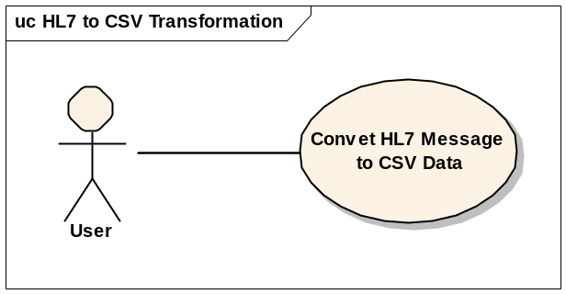

Brief Description
In this use case the actor initiates the process of loading a HL7 version message xml file and specifying the mapping between CSV and HL7 message. The system validates the HL7 message and converts it into a CSV data saving as a plain text file.

Primary Actor
Analyst

Preconditions

A HL7 version 3 message is ready
A validate HL7 version 3 message has been created with the caAdapter tool or other messaging tools.

A mapping is defined
A validate mapping file has been created with caAdapter tools to map a CSV specification and a HL7 version 3 message specification.

Basic Flow of Events
1. The analyst invokes the transformation process by select "Transform HL7 to CSV" action item from menu bar. 2. The system pops up a dialog and prompts the analyst to enter the name and location of the HL7 message and the mapping file.3. The Analyst enters the name and location of the files or selects them with file browser.4. The system reads and validates the given HL7 message xml file.5. The system converts the HL7 message into a CSV data saving it as a plain text file.

Alternative Flow of Events
1. Message Validation Failed: If the system failed in validating the input HL7 message a. System displays the HL7 format validation error message b. System prompts user to select another HL7 message file. (Return to step 2)
2. Message Transformation Failed: If the system failed in converting the HL7 message with the given CSV to HL7 mapping. a. System displays mapping error message b. System promotes user to select another mapping file or setup new mapping file c. System prompts user to select another mapping file. (Return to step 2) d. User setup new CSV to HL7 mapping with give CSV specification and HL7 specification.

Post Conditions

Message transformation success
SUCCESS CONDITION: A HL7 version 3 message has been converted to a CSV data and saved as a plain text file with the location of the original HL7 message xml file.

Message Validation Failed
ERROR CONDITION: Failed in validating HL7 message

Message Transformation Failed

ERROR CONDITION: Failed in converting the specified HL7 message to a CSV data

Overall Requirements

Requirements Prioritization

Priority | Use Case Name | Supp Requirement Ref #

Data Definitions

Sign Off

Approval

Workspace General Contractor Rep Print Name Date
Architecture Workspace Rep Print Name Date
VCDE Workspace Rep Print Name Date
Workspace Working Group Rep Print Name Date
NCICB Rep Print Name Date

